**Hiring Process Analytics**

**Statistics**

**Project Description**

In this project, we will perform statistical analysis in order to to understand hiring process. Hiring process is the fundamental and the most important function of a company. Here, the MNCs get to know about the major underlying trends about the hiring process. Trends such as- number of rejections, number of interviews, types of jobs, vacancies etc. are important for a company to analyse before hiring freshers or any other individual.

**Approach**

Using MS Excel we will do statistical analysis of data records of companies previous hiring.

**Tech-Stack Used: Microsoft Excel 2016**

* MS Excel 2016 is a spreadsheet program where one can record data in the form of tables.
* It is easy to analyse numerical data in an Excel spreadsheet.
* It features calculation or computation capabilities, graphing tools, pivot tables, and a macro programming language called Visual Basic for Applications (VBA).

**Insights:**

1. **Hiring:** Process of intaking of people into an organization for different kinds of positions.

* Functions used: **COUNTIFS**
* 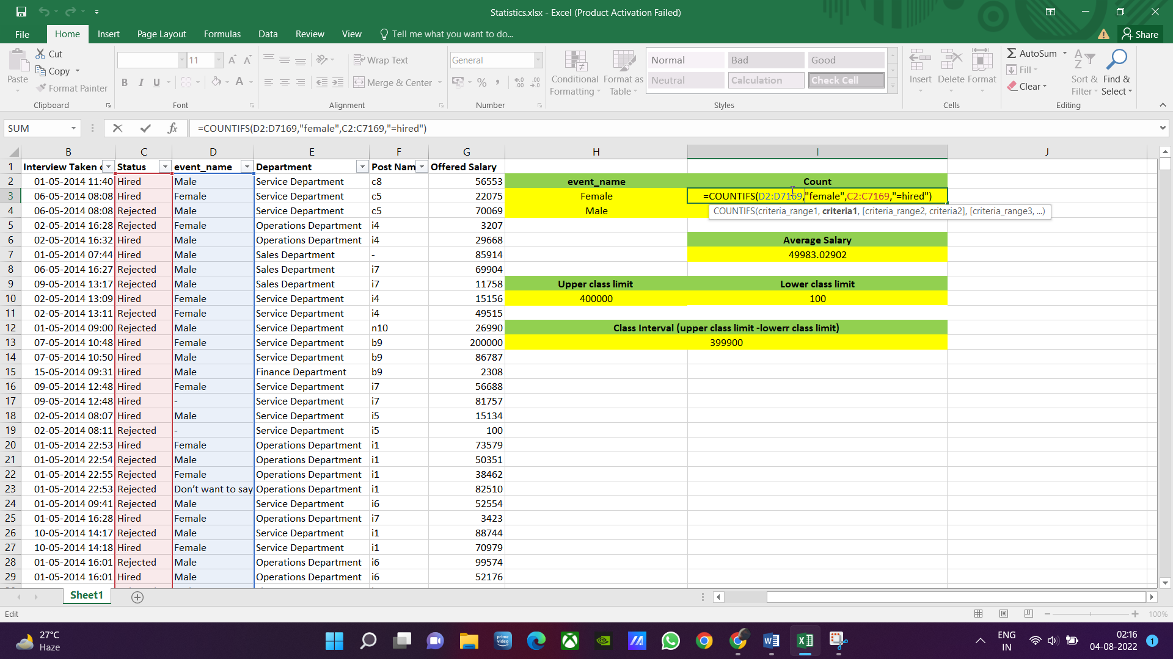Generic Formulas:
* Formulas:

To calculate no of hired women:



To calculate no of hired men:



**No of males and females are hired are as follow:**



Graphical representation:

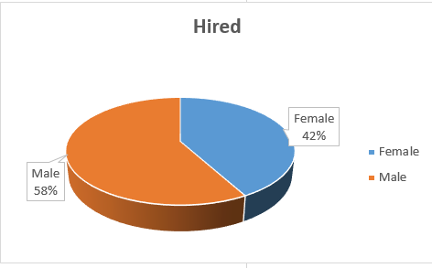

---------------------------------------------------------------------------------------------------

1. **Average Salary:** Adding all the salaries for a select group of employees and then dividing the sum by the number of employees in the group.

* Functions used: **AVERAGEIFS**
* Generic Formulas:
* Formulas:

**Average salary offered in this company:**



---------------------------------------------------------------------------------------------------

1. **Class Intervals:** The class interval is the difference between the upper class limit and the lower class limit.

* Functions used:

1. **MAX**
2. **MIN**

* Generic Formulas:

MAX:

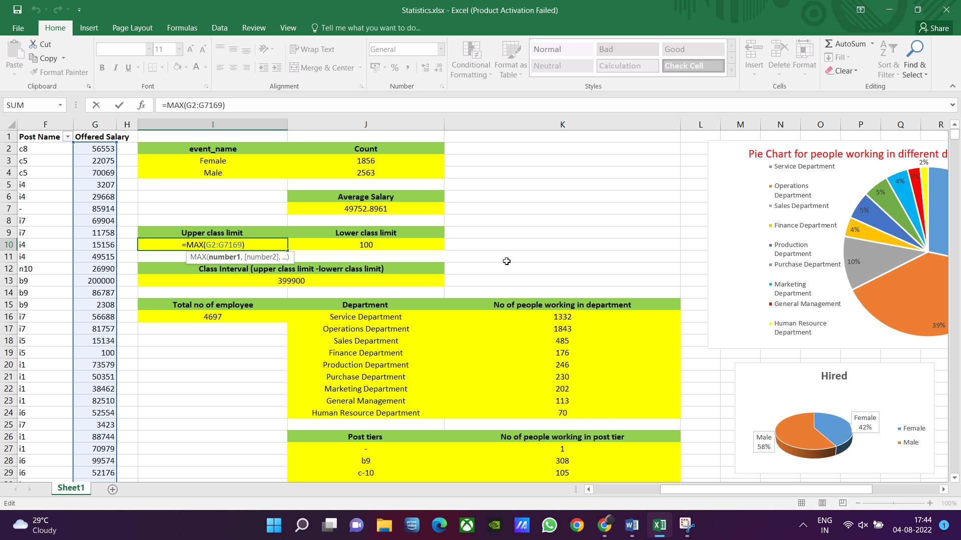

MIN:

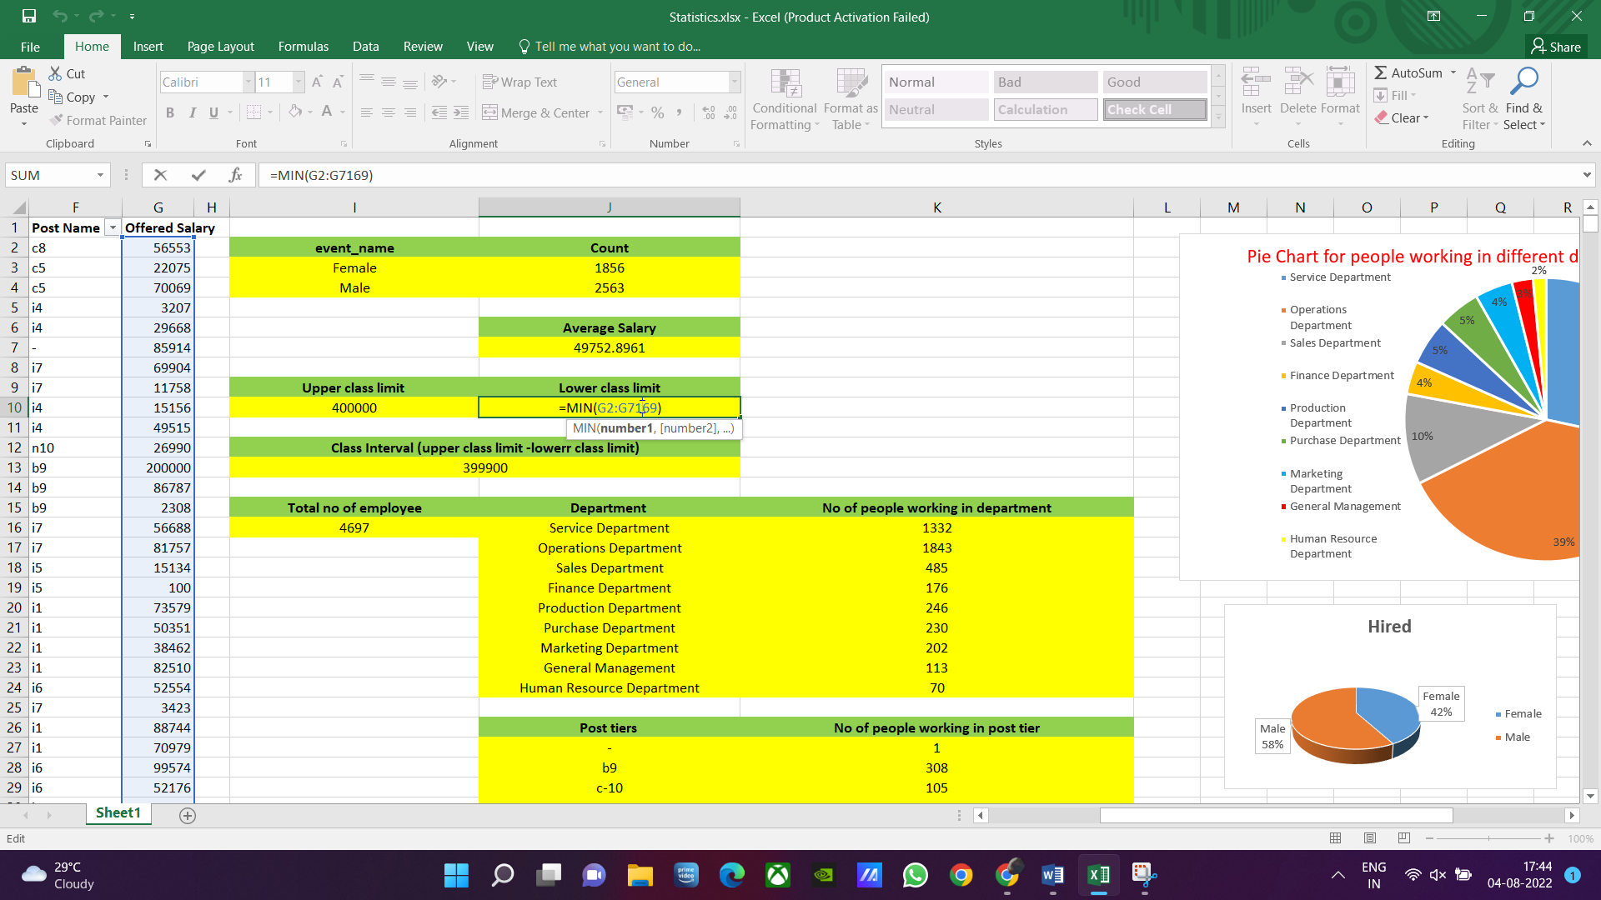

* Formulas:

To calculate upper limit:



 To calculate lower limit:

To calculate class interval:



**Class intervals for salary in the company:**



WHERE,



---------------------------------------------------------------------------------------------------

1. **Charts and Plots:**This is one of the most important part of analysis to visualize the data.

* Functions used:

1. **COUNTIFS**
2. **CHART**

* Generic Formulas:



* Formulas:

1. To calculate no of employee working in Service Department:
2. To calculate no of employee working in Operation Department:
3. To calculate no of employee working in Sales Department:
4. To calculate no of employee working in Finance Department:
5. To calculate no of employee working in Production Department:
6. To calculate no of employee working in Purchase Department:
7. To calculate no of employee working in Marketing Department:
8. To calculate no of employee working in General Management:
9. To calculate no of employee working in Human Resource Department:

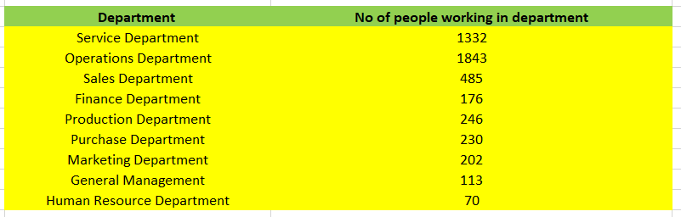Derived pivot table:

Using above pivot table a pie chart is obtained

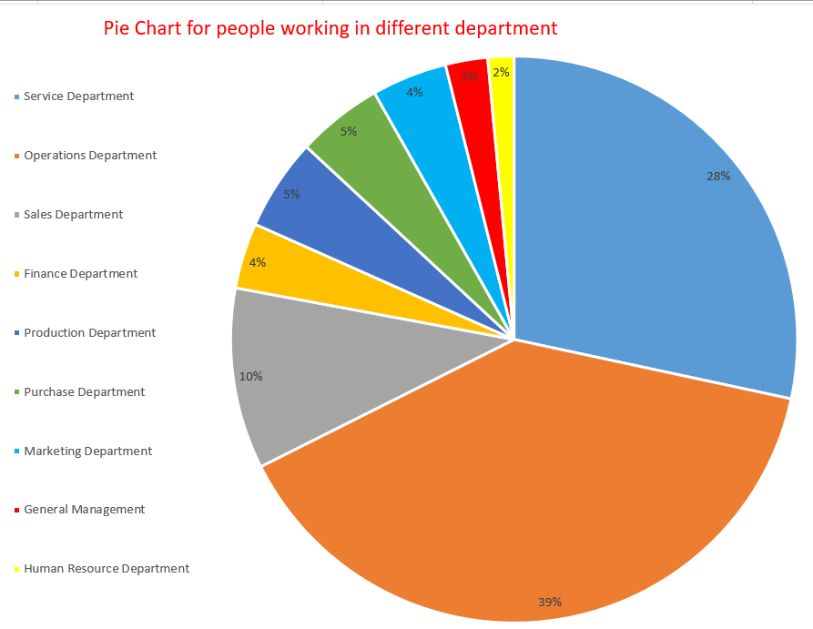**Pie Chart to show proportion of people working different department is as follow:**

---------------------------------------------------------------------------------------------------

1. **Charts:**Use different charts and graphs to perform the task representing the data.  
   **Your task:**Represent different post tiers using chart/graph?

* Functions used:

1. **COUNTIFS**
2. **CHART**

* Generic Formulas:



* Formulas:

1.  To calculate no of employee working in tire – (unknown):
2.  To calculate no of employee working in b9 tire:
3.  To calculate no of employee working in c-10 tire:
4.  To calculate no of employee working in c5 tire:
5. To calculate no of employee working in c8 tire:



1.  To calculate no of employee working c9 in tire:
2.  To calculate no of employee working in i1 tire:
3. To calculate no of employee working in i4 tire:



1. To calculate no of employee working in i5 tire:



1. To calculate no of employee working in i6 tire:



1.  To calculate no of employee working in i7 tire:
2.  To calculate no of employee working in m6 tire:
3. To calculate no of employee working in m7 tire:



1. To calculate no of employee working in n10 tire:



1. To calculate no of employee working in n6 tire:



1. To calculate no of employee working in n9 tire:



* Derived pivot table:

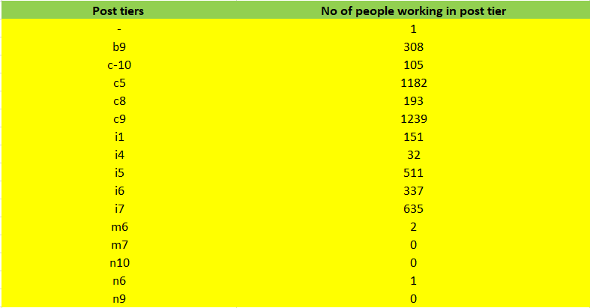

Using above pivot table a chart/graph is obtained

**Representing post tiers using chart and graph:**

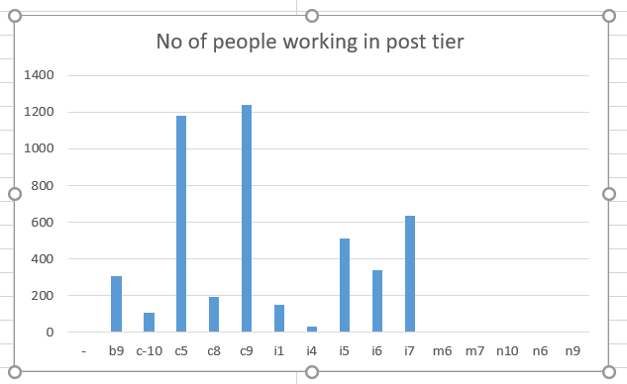 Graph:

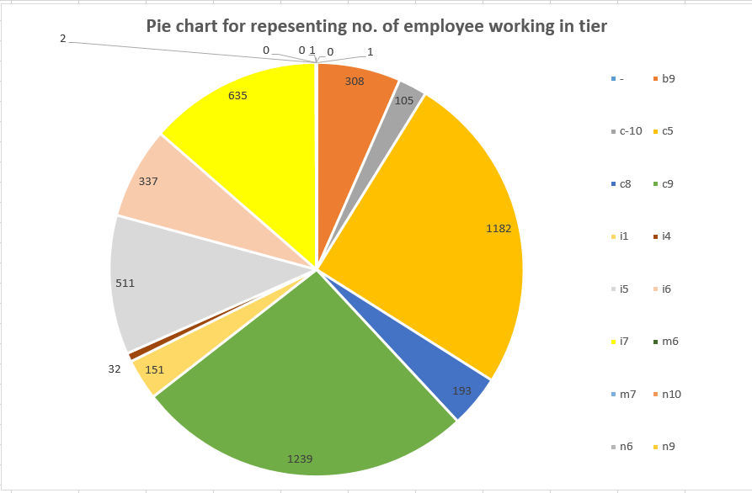Pie Chart:

**Result:**

* In this project I have gain practical hands on knowledge to analyse numerical data in an Excel spreadsheet.
* Learnt various MS Excel functions and formulas that can be used in many companies in day to day analysis data record in their company